YouSaveIt WEBSITE
Interface Design Document


TEAM: EAGLE
Version: V.1.0

Revision History
Date | Version | Description | Custodian/Organization
29/09/2013 | 1.0 | Initial publication. | Trần Công Bình

Table of Contents
1. Introduction 2
1.1 Purpose 2
1.2 Scope 2
2. Description of Project 3
2.1 Business need 3
2.2 Benefits 3
2.3 High level features 3
2.4 Additional features 4
2.5 Non-functional 4
2.6 Estimated Project Costs 5
3. Resource 6
3.1 Human resource 6
3.2 Technology 7
3.3 System environments 7
4. Process 8
4.1 Process overview 8
2.1.1. Advantage 8
4.2 Work Breakdown Structure 9
4.3 Plan 9
Appendix A: Glossary 10
Appendix B: Reference Documents 11
Appendix C: Approval 12

Introduction

Purpose
- This document helps to better understand the interface of the YouSaveIt Website, detailed specification components and function of the website.
- With this document, the development team can understand the structure and composition to create a consistent and complete system.

Scope
- Overview of the stages and modules of the software.
- Create complete interfaces, and descript them clearly.

Reference
- SRS document
- Architect Design Document
- Database Design Document

List of interface
No. | Interface code | Interface name | Detail
1 | ID01 | Homepage interface | Homepage, where display feature & latest stuff
2 | ID02 | Login interface | User inputs username and password to access more function
3 | ID03 | Login success interface | Display brief information of user
4 | ID04 | Forgot password interface | It help user to get back their password
5 | ID05 | Register interface | It allow user to create new account
6 | ID06 | Result for search | Display information of stuff which user input in search form
7 | ID07 | Posting interface | The form that user put information about their stuff in
8 | ID08 | Category-stuff interface | Display all stuff in category which user choose
9 | ID09 | Comment interface | The form that user put their comment to the post
10 | ID10 | Comment detail interface | Display detail comment of stuff which user input in comment form
11 | ID11 | Posting detail interface | Display detail information of stuff which user input in post form

Interface Specification

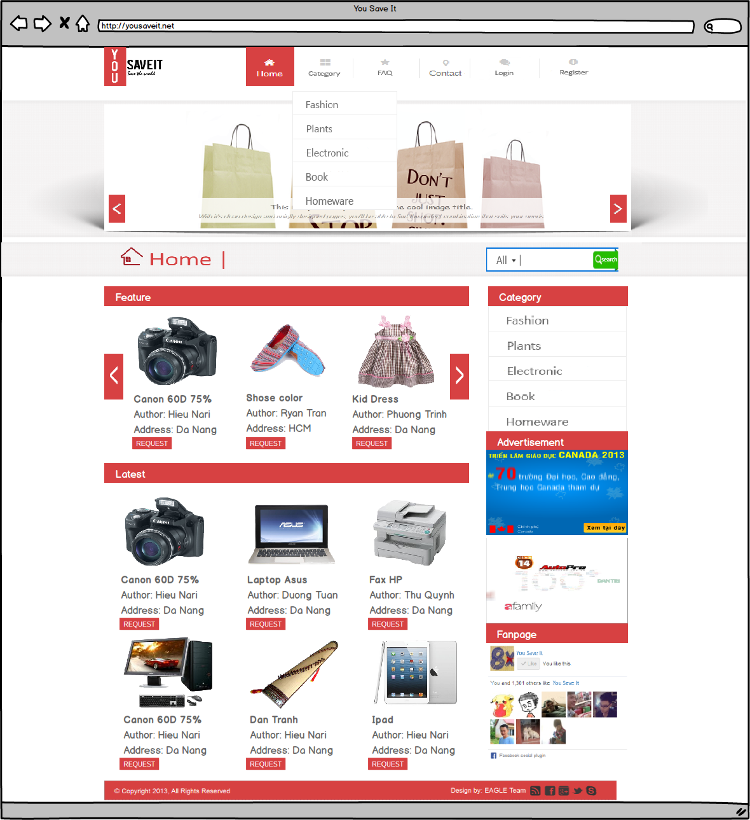
Home page interface
Figure1: Homepage interface

Table 1: Detail description Homepage interface
Homepage Interface |  |  | Code: ID01
No. | Field Name | Type | Target | Comment
1 | Home | Link | Direct to the homepage page
2 | Category | Link | “Category popup” will display when click on “Category link” | “Category popup” includes all category in table category on database
3 | FAQ | Link | Direct to the FAQ page
4 | Login | Link | Direct to the login form
5 | Register | Link | Direct to the register form
6 | Slider | Slider | Slide the image banner
7 | Feature | Container | Display short information about topic | “Feature” will slide each 3 topic/1 time every 30s
8 | Latest | Container | Display the newest topic | Limit 6 topic
9 | Category | Container | List all category in database
10 | Advertisement | Container | Display banner for ad | Slide up
11 | Fanpage | Container | Display information about fanpage of website | Use Facebook API
12 | All | Link | “All popup” will display when click on “All” | “All popup” includes all category in table category on database
13 | Search | Button | Display results when click on it
14 | Search form | Textbox | Allow user to input search keyword

Login interface
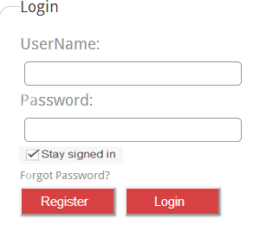

Figure 2: Login interface
Table 2: Detail description login interface
Login interface |  |  |  | Code: ID02
No. | Field Name | Type | Null/ Not null | Target | Comment
1 | Login | Field set |  | Text for guide | Color = black Font size = 16
2 | User name | Label |  | Text for guide | Color = black Font size = 16
3 | User name | Textbox | Not Null | User input their username on it | Size: 260x30px
4 | Password | Label |  | Text for guide | Color = black Font size = 16
5 | Password | Textbox | Not Null | User input their password on it | Text mask Size: 260x30px
6 | Stay signed in | Label |  | Text for guide | Color = black Font size = 16
7 | Stay signed in | Checkbox |  | Save user account
8 | Forgot password | Link |  | Direct to forgot password link | Font size = 16 Color = blue
9 | Register | Button |  | Direct to register form | Color = #D74142
10 | Login | Button |  | Check username and password are correct  - If they are valid login success occur  - Else, system will display an error message | Color = #D74142

Login success interface
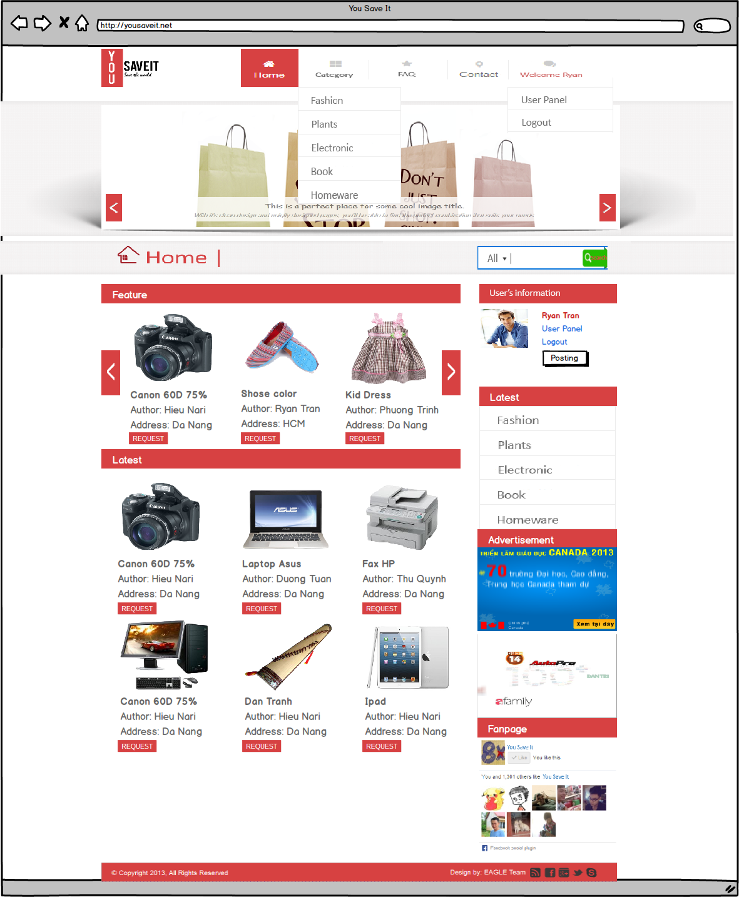
Figure 3: Login success interface

Table 3: Detail description login success interface
Login success Interface |  |  | Code: ID03
No. | Field Name | Type | Target | Comment
1 | Welcome Ryan | Link | “CP popup” will display when click on “Welcome Ryan” | “CP popup” includes “User panel” & “Logout” link
2 | User’s information | Container | Container displays brief of user’s information after logging. | Container includes user’s avatar, username label, and link to “CP panel” & “Logout”
3 | Posting | Button | Direct to posting form

Forgot password interface
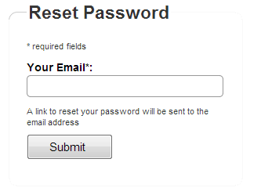

Figure 4: Forgot password interface

Table 4: Detail description forgot password interface
Login success Interface |  |  | Code: ID04
No. | Field Name | Type | Target | Comment
1 | Reset password | Field set | Text for guide | Color = black  Size = 18
2 | Required fields | Label | Text for guide | Color = black  Size = 14
3 | Your email | Label | Text for guide | Color = black  Size = 16
4 | Your email | Textbox | Allow user input their registered email to recovered their password  This textbox required not null | Size 260x30px
5 | A link to reset… | Label | Text for guide | Color = black  Size = 14
6 | Submit | Button | Check email textbox  - If the email valid then email to user with their new password  - Else, display error message | Size 25x25px

Register interface
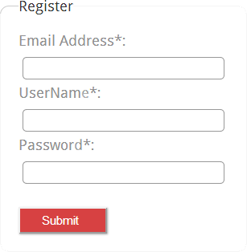

Figure 5: Register interface
Table 5: Detail description register interface
Register interface |  |  |  | Code: ID05
No. | Field Name | Type | Null/ Not null | Target | Comment
1 | Register | Field set |  | Text for guide | Color = black Font size = 16
2 | Email address | Label |  | Text for guide | Color = black Font size = 16
3 | Email address | Textbox | Not Null | User input their email address on it | Size: 260x30px
4 | User name | Textbox |  | Text for guide | Color = black Font size = 16
5 | User name | Label | Not Null | User input their user name on it | Size: 260x30px
6 | Password | Label |  | Text for guide | Color = black Font size = 16
7 | Password | Textbox | Not Null | User input their password on it | Text mask Size: 260x30px
8 | Submit | Button |  | Check email, username and password are valid  - If they are valid create new account  - Else, system will display an error message | Color = #D74142

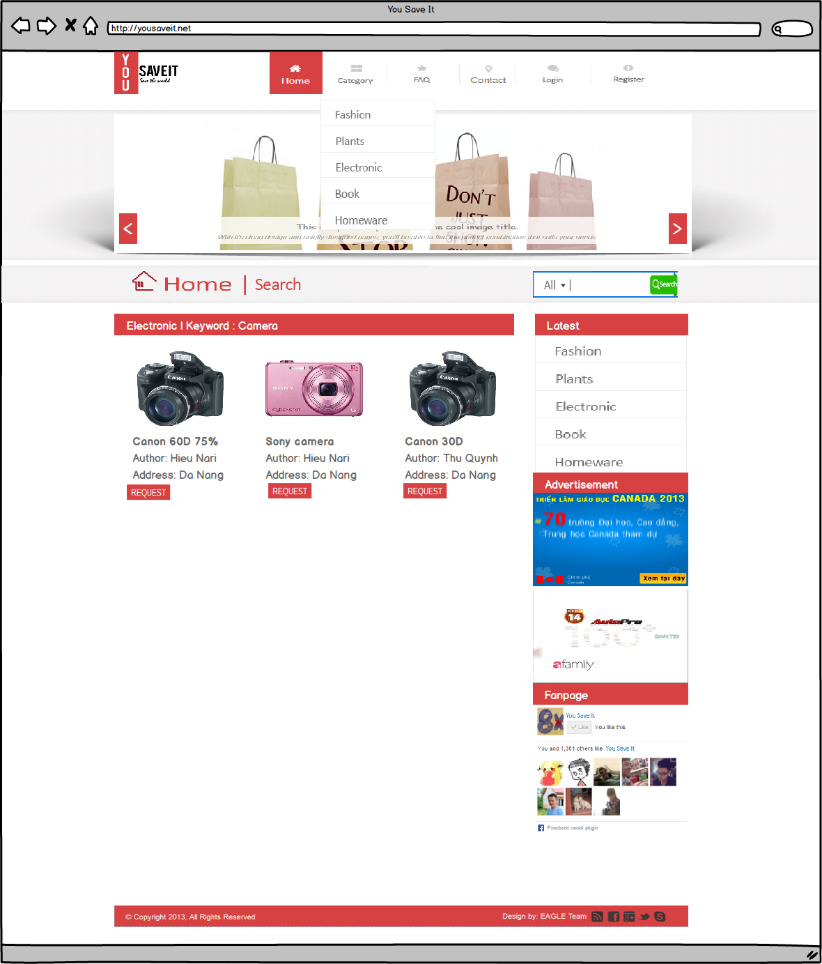
Result for search interface
Figure 6: Result for search interface

Table 6: Detail description result for search interface
Result for search interface |  |  |  | Code: ID06
No. | Field Name | Type | Null/ Not null | Target | Comment
1 | Electronic | Keyword… | Container |  | Display all result for each keyword

Posting interface
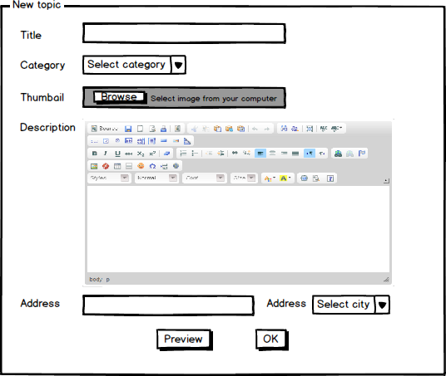
Figure7: Posting interface

Table 7: Detail description posting interface
Posting interface |  |  |  | Code: ID07
No. | Field Name | Type | Null/ Not null | Target | Comment
1 | Title | Label |  | Text for guide | Color = black Font size = 16
2 | Title | Input | Not null | User input the title of topic on it | Size: 450x30px
3 | Category | Label |  | Text for guide | Color = black Font size = 16
4 | Category | Dropdown box | Not null | Display all category on database
5 | Thumbnail | Label |  | Text for guide | Color = black Font size = 16
6 | Thumbnail | Container | Not null | Upload image from user’s computer
7 | Description | Label |  | Text for guide | Color = black Font size = 16
8 | Description | Container | Not null | User put description of their topic | Use ckeditor to enhance text
9 | Address | Label |  | Text for guide | Color = black Font size = 16
10 | Address | Textbox | Not null | User put trade address on it
11 | City | Label |  | Text for guide | Color = black Font size = 16
12 | City | Dropdown box | Not null | User select city of trade address
13 | Preview | Button |  | Display the draft of topic
14 | Ok | Button |  | Check all field if valid then post topic on database

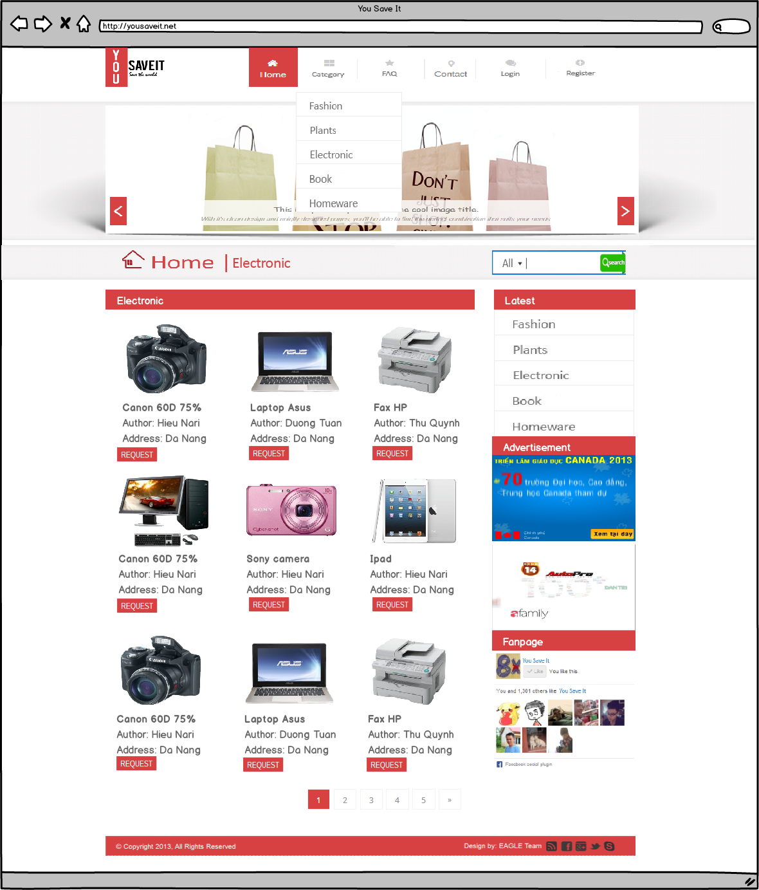
Category-stuff interface

Figure 8: Category-stuff interface
Table 8: Detail description category-stuff interface
Category-stuff interface |  |  |  | Code: ID08
No. | Field Name | Type | Null/ Not null | Target | Comment
1 | Electronic | Container |  | Display all topic in category which user choose from category popup

Comment interface
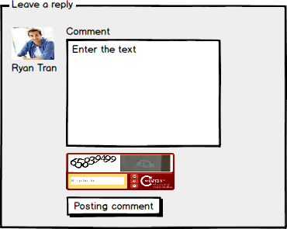

Figure 9: Comment interface
Table 9: Comment interface
Comment interface |  |  |  | Code: ID09
No. | Field Name | Type | Null/ Not null | Target | Comment
1 | Ryan Tran | Container |  | Display username and avatar
2 | Comment | Label |  | Text for guide | Color = black Size = 16
3 | Comment | Textbox |  | User reply for topic
4 | Captcha | Container |  | This is use to anti-spam
5 | Posting comment | Button |  | Check all field if valid then posting comment to topic

Comment detail interface
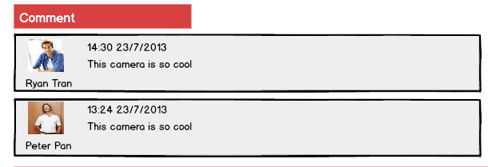

Figure 10: Comment detail interface

Table 10: Comment detail interface
Comment detail interface |  |  |  | Code: ID10
No. | Field Name | Type | Null/ Not null | Target | Comment
1 | Ryan Tran | Container |  | Display username and avatar
2 | 14:30 23/7/2013 | Label/Date |  | Display the time this comment was posted
3 | This camera is… | Label/Text |  | Display content of the comment

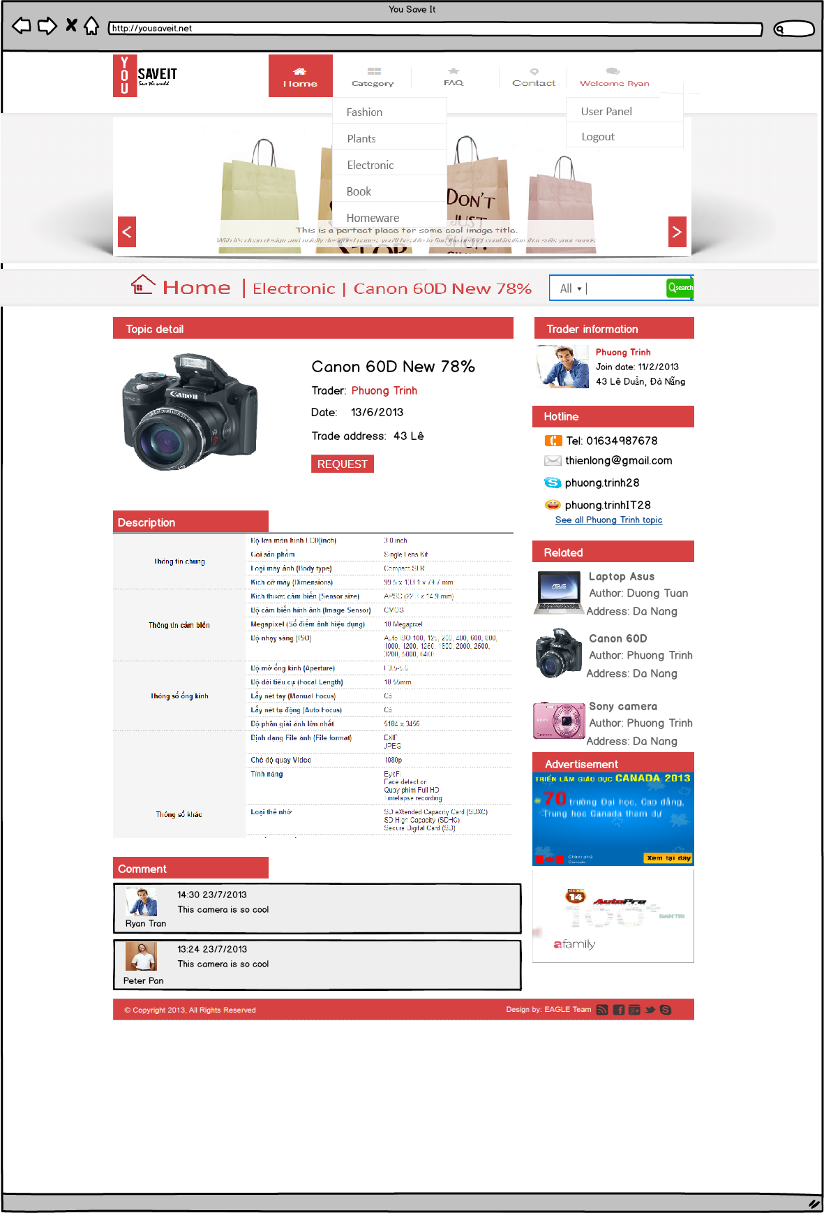
Posting detail interface
Figure 11: Posting detail interface

Table 11: Detail description Posting detail interface
Posting detail Interface |  |  | Code: ID11
No. | Field Name | Type | Target | Comment
1 | Trader information | Container | Display trader username, date join website and address
2 | Hotline | Container | Display the ways can contact to the trader | Includes email, yahoo, telephone and Skype of the trader
3 | Related | Container | Display topic that related with the detail topic
4 | Topic detail | Container | Display information about topic | Includes thumbnail image, the title, trader username, date of the topic and address for trade
5 | Description | Container | Display the content of the topic

Appendix A: Approval
Prepared by | Signature | Date
Tran Cong Binh
K16CMU-TTT
Approved by | Signature | Date
Tran Kim Sanh
Mentor
Duy Tan University

Nguyen Trinh Trung Duong
Mentor
Duy Tan University

